**Mechanics Of Solids**

**Prof. Priyanka Ghosh**

**Department of Civil Engineering**

**Indian Institute of Technology, Kanpur**

**Lecture - 48**

**Shear Stress Distribution**

*Keywords: Rectangular beams, bending and shear stress distribution*

Welcome back to the course mechanics of solids. So, if you recall the last lecture, we talked about the shear stress calculation or we had derived the expression for the shear stress. When your bending moment is not constant, that is not the pure bending situation. When bending moment is varying, your shear force does exist and based on that you get the shear stress on the cross section right.

Now, as you know that most of the times you will be getting the rectangular cross section of the beam that is more common. So, let us see how we can extend the same knowledge, same thing whatever we have learnt to find out the shear stress. How it can be obtained for the rectangular cross section, or the square cross section or whatever you generally get in the common practice.

So now we already know from our equilibrium condition that *x* /*x* plus *xy* /*y* is equal to zero, and *xy* /*x* plus *y* /*y is* equal to 0.

(Refer Slide Time: 01:18)

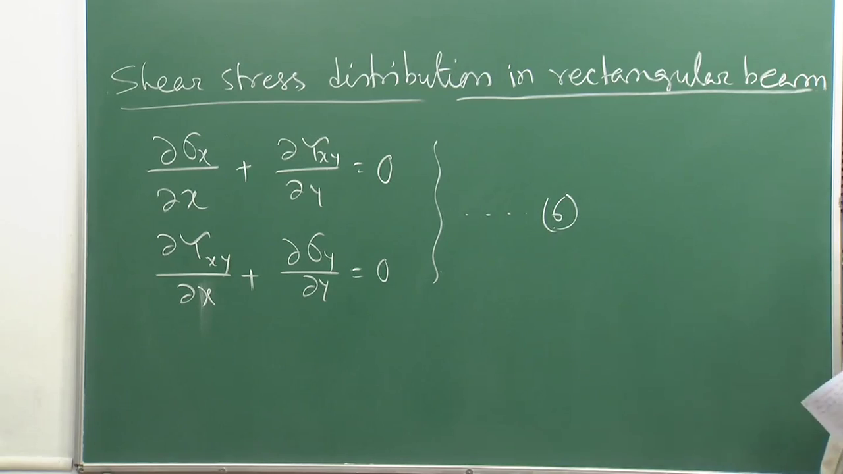

Thus you know that your equilibrium equation is right.

Now if the shear force does not vary with *x* axis, as we discussed in the last lecture. Because there is no transverse load, the shear force is not varying with *x* and only the bending moment is varying. Since bending moment is varying, therefore shear force exists but they are not varying with *x*.

Then if shear force does not vary with *x,* the shear stress will also be independent of *x*, agreed or not? If there is no variation of the shear force, then how the shear stress will be varying with *x*? So, shear stress will also be independent with respect to *x*. Then in the second equation, this part is 0 because shear stress is not having any variation with *x*.

So, the first term of the second equation is simply zero, and we know from our previous discussion that in case of this type or this class of problem like bending and this shear force, your *y* is also 0. So, by default, the second equation is automatically getting satisfied. So, we need not think about that.

Now, we will be only dealing with the first equation, which is more meaningful for us. So, from the first equation, we can write simply *xy* /*y* is equal to *x* /*x*.

(Refer Slide Time: 03:21)

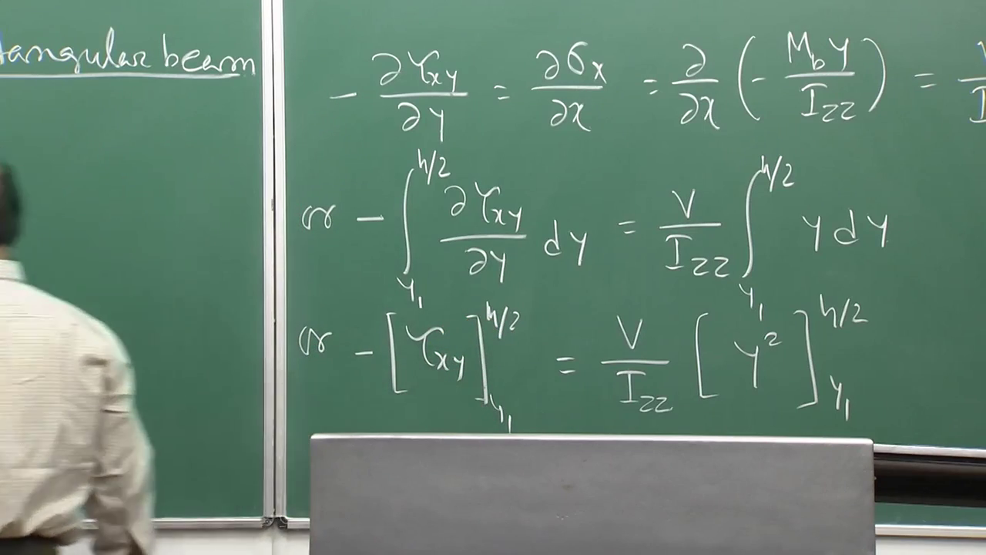

It can be written as  *x* of minus *Mb y* by *Izz* that is expression for *x*, which is nothing but *V y by* *Izz*. Because *Mb* *x* is nothing but *V*, that is the variation of bending moment with respect to *x,* nothing but shear force *V*. So, *V y* by *Izz* right. It is minus *V*, minus, minus will be becoming plus.